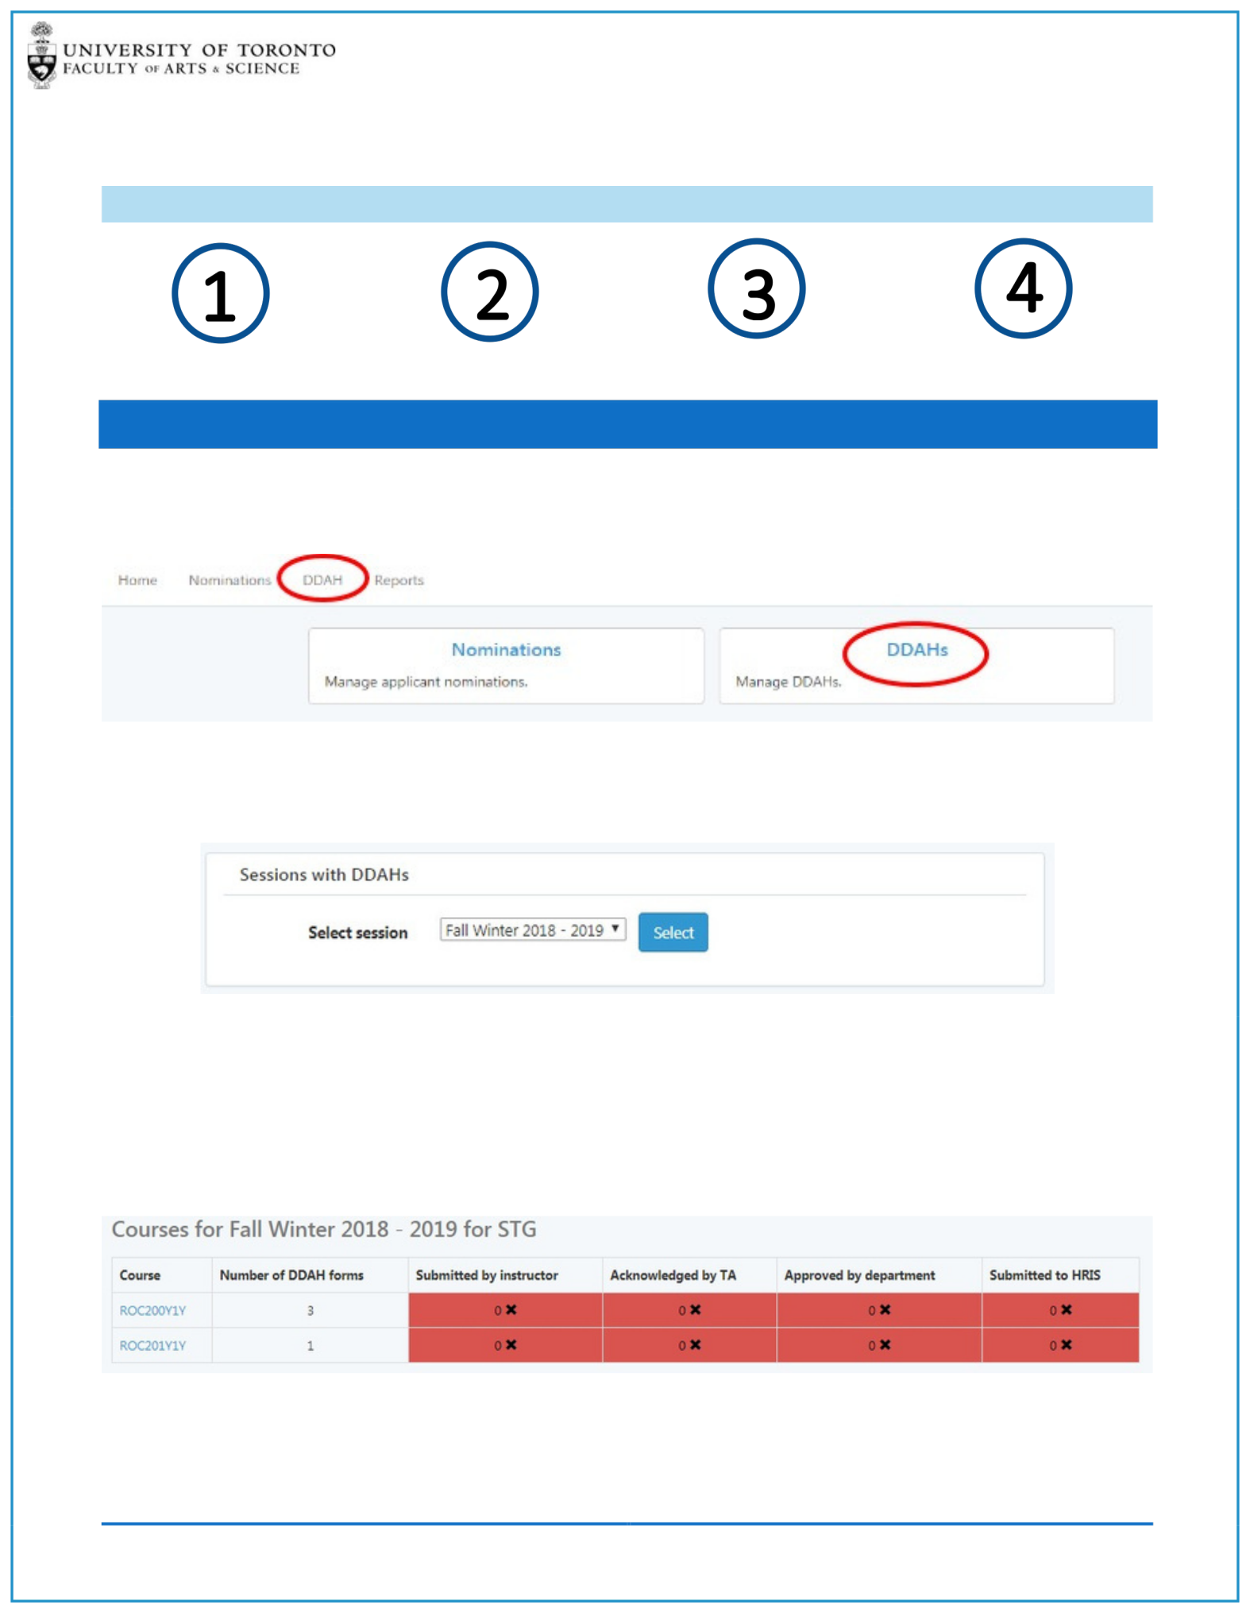ONLINE DDAH

TIP SHEET FOR INSTRUCTORS

Locate your Course Start a DDAH Form Add Tasks & Hours Submit DDAH

STEP 1: LOCATE YOUR COURSE

After Logging onto the TAShip System\*, you will be able to navigate to the DDAH Dashboard by either clicking on the DDAH menu item or by clicking on the DDAHs link.

\*PLEASE NOTE: Contact your department’s TA Coordinator for system login details.

If prompted select the correct Session.

The DDAH Dashboard will display all the courses that you are teaching for the selected session. The Dashboard displays the Course code and the number of DDAH forms that need to be created and submitted for that course.

The remaining columns display the DDAH workflow steps: Submitted by Instructor, Acknowledged by TA, Approved by Department and Submitted to HRIS

At the start of the process all the workflow columns will be set at 0 and will increase as the DDAH form completes a different part of the workflow. The workflow cell will remain red, and will only turn green once all the DDAH forms for that workflow step has been completed.

ONLINE DDAH - INSTRUCTOR TIP SHEET

1

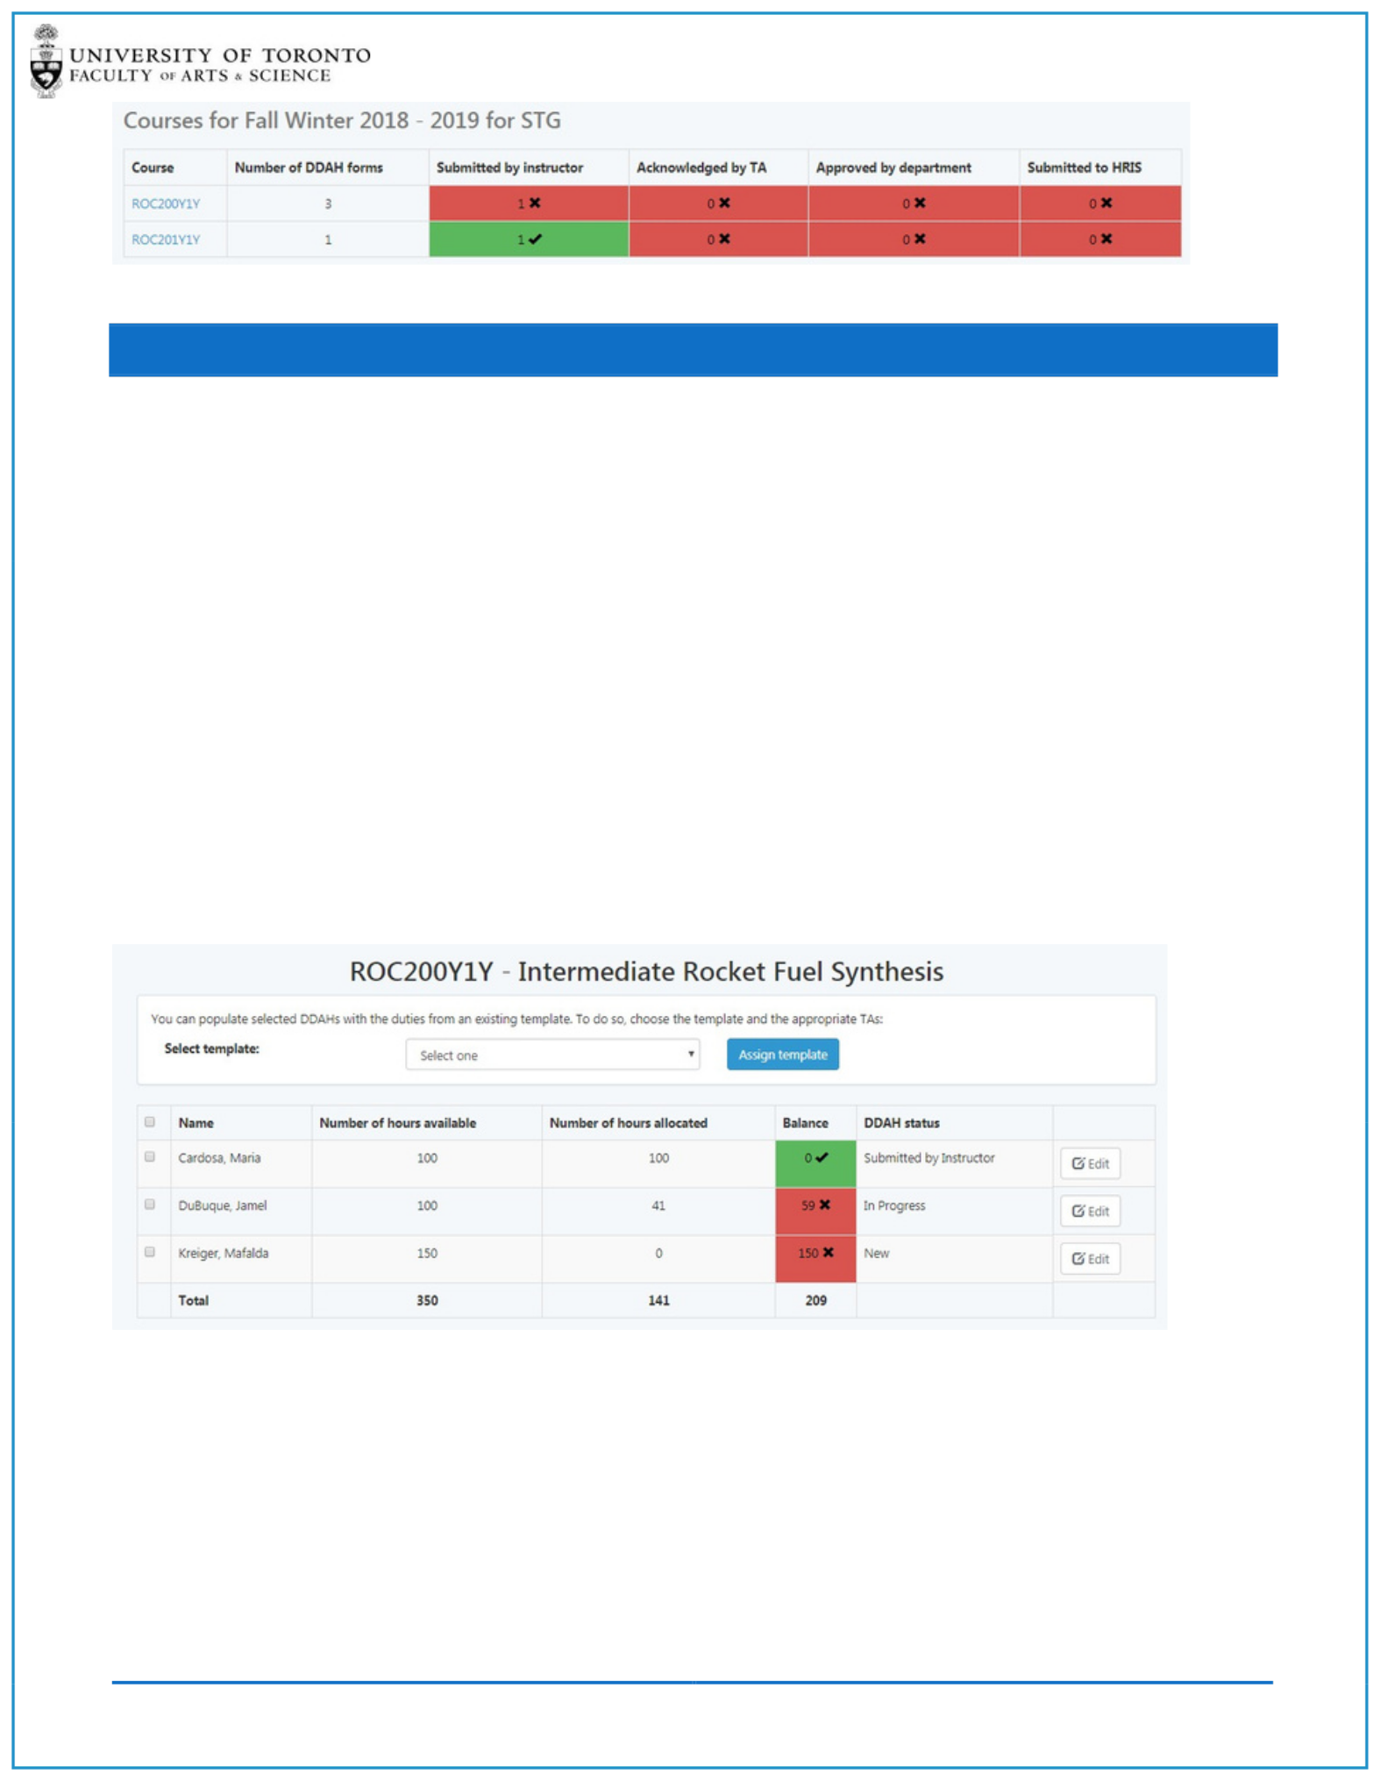

STEP 2: START A DDAH FORM

From the DDAH Dashboard click on the Course Code to navigate to the Course Dashboard.

The Course Dashboard displays:

Individual TAs

Number of Hours Available (based on the Offer made within the TAShip web Application) Number of Hours Allocated

Balance (difference between Hours Available and Hours Allocated) DDAH Status

The Number of hours allocated and corresponding balance will be updated as you add hours to the DDAH. Once Hours Available and Hours Allocated are equal, the balance will be zero and the field will turn green.

*In the example below, 1 DDAH form has already been completed, 1 DDAH form is In Progress and 1 DDAH form hasn’t been started.*

There are two ways to start your DDAH form:

1 – If your department has created templates you can select a template and the TA(s) and then click on Assign Template button. This will apply the selected template to the DDAH form prepopulating it with tasks and hours. You can then click on the Edit button to review or make changes to the DDAH.

2 – You can create an empty DDAH by not selecting a template but by clicking on the Edit button. You will be taken to an empty DDAH for that TA and you can start editing the DDAH form by clicking on the Add Task button.

ONLINE DDAH - INSTRUCTOR TIP SHEET 2

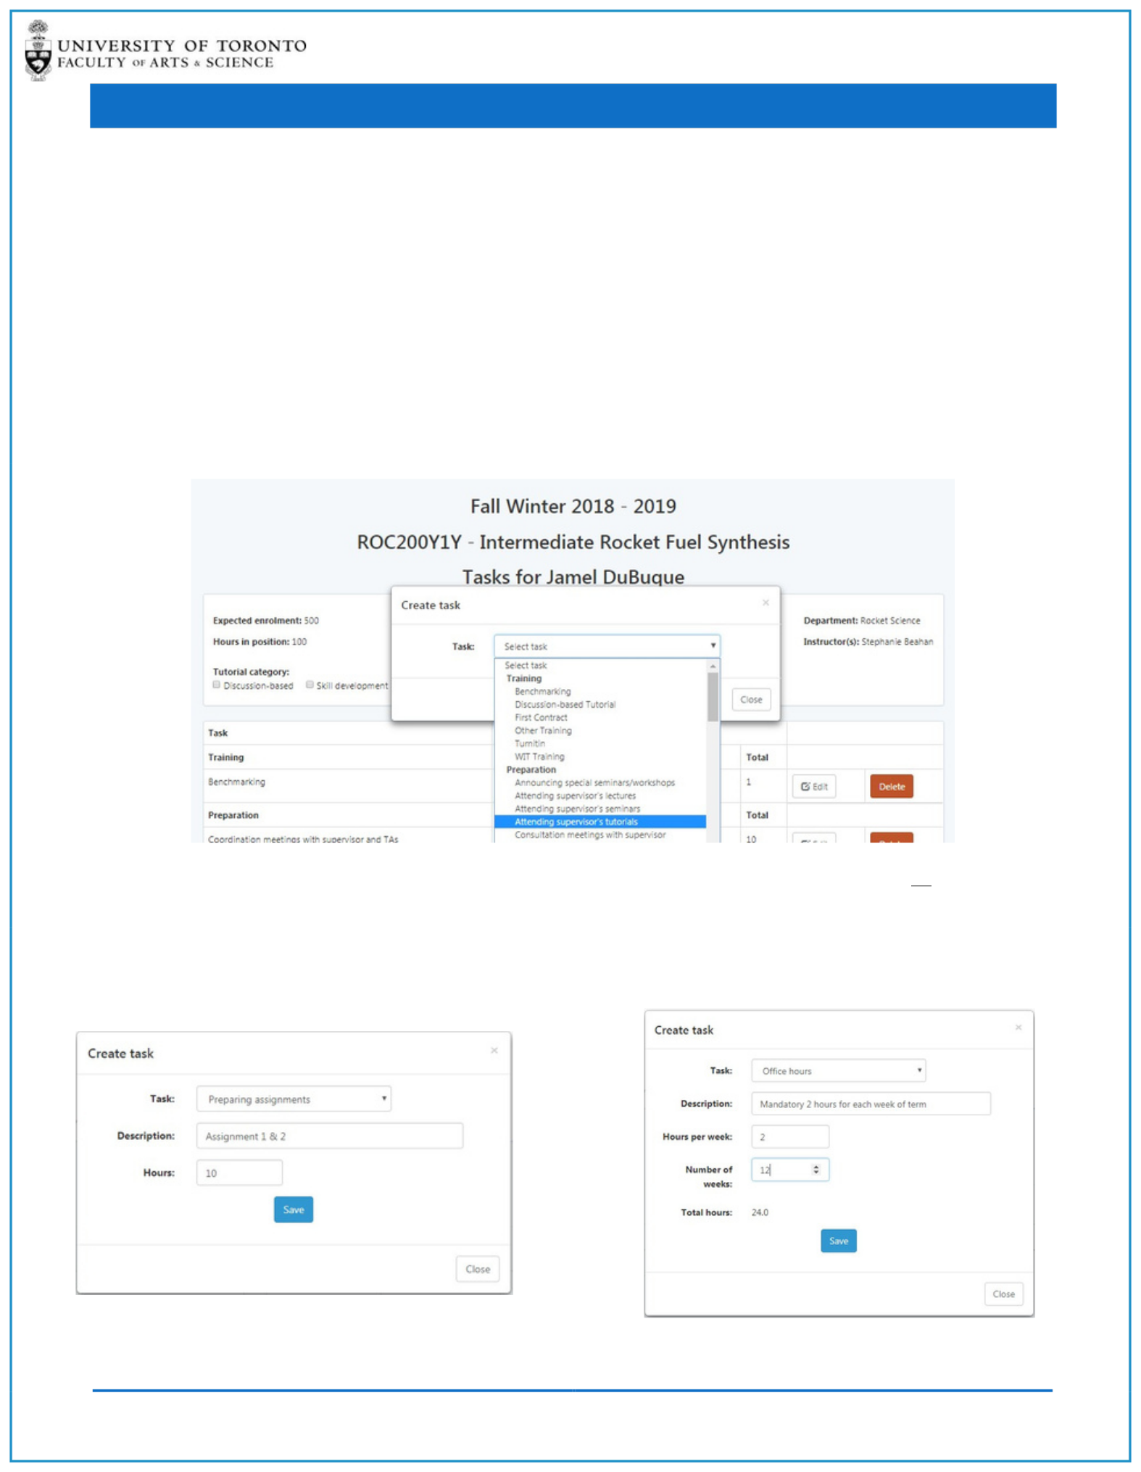STEP 3: ADD TASKS

The DDAH form will display the following information:

Course Code Expected Enrolment (if entered by Dep’t)

Course Name Hours in Position, Total Hours and Hours Remaining

TA Name Tutorial Categories

Department Name DDAH Task Names and Hours (grouped by Category)

Instructor Name DDAH Status and Version Number

To stat populating the DDAH form with tasks click on the Add Task button located at the bottom right-

hand corner of the screen. The Add Task window lists all the tasks that are available for you to use.

You cannot edit the Task Name but you can add a Description.

Depending on your Department setup you will either be prompted to enter Total Hours or for certain tasks you may be prompted to enter in task attributes for example Number of Hours and Hours per Week and the system will take these inputs and calculate total hours for you.

*Example: Task with no attributes* *Example: Task with Weekly Attributes*

ONLINE DDAH - INSTRUCTOR TIP SHEET 3

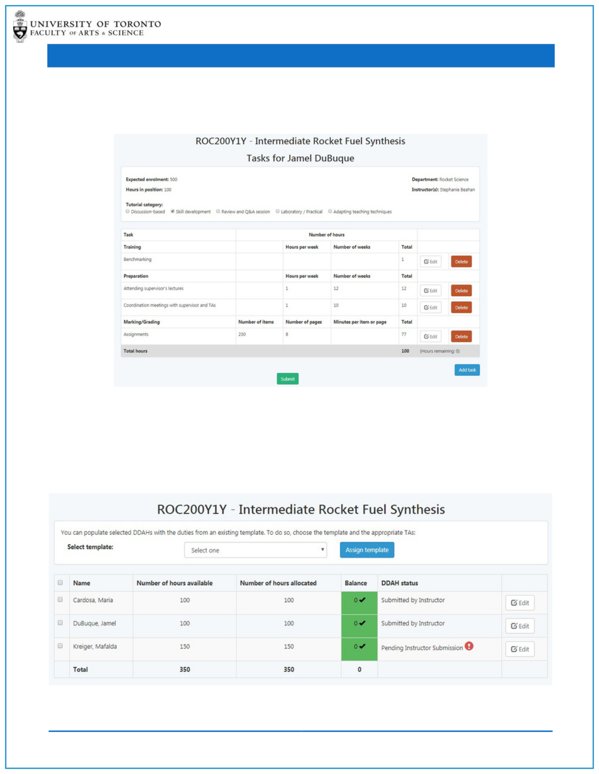STEP 4: SUBMIT DDAH

As you add tasks to the DDAH form the Hours Remaining total will adjust dynamically. Once the Hours Remaining is 0 the status will change to Pending Instructor Submission and you will be able to Submit the DDAH.

PLEASE NOTE: You will not be able to submit the DDAH form until the Hours Remaining Total is zero.

When you are ready to submit the DDAH click on the Submit button, this will initiate the following actions: (1) The status will change to Submitted by Instructor, (2) the TA will be sent an email notifying them that the DDAH is ready for their Acknowledgement and (3) the Submitted by Instructor step on the DDAH Dashboard will be updated.

ONLINE DDAH - INSTRUCTOR TIP SHEET 4