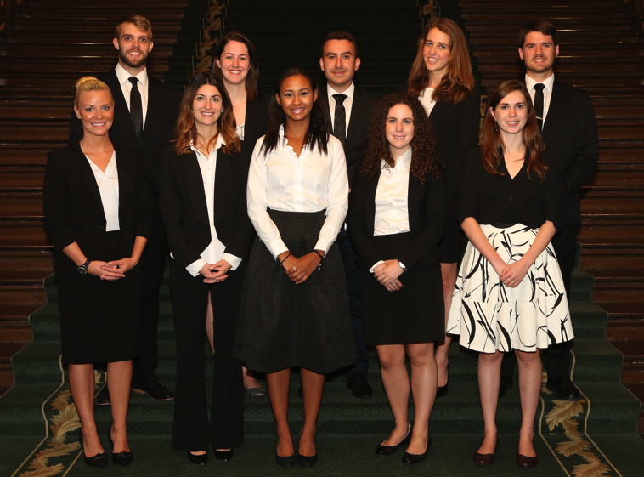

OLIP is a non-partisan internship that offers an intimate exposure to how politics works at Queen's Park. Interns work with Members of Provincial Parliament from both the opposition and government. The programme also features meetings with prominent political figures, **educational trips** to various legislatures, and a **$20,000** stipend.

**Apply to the Ontario Legislature Internship Programme**

**Eligibility & Application**

* Open to recent graduates of Canadian universities.
* Applicants must show an interest in and knowledge of Ontario’s legislative process.
* Each application must be **mailed** to the Progamme office by **Monday, January 31st, 2016.**

For more information, please contact Kimberley Judd at **kjudd@ola.org** or visit **www.olipinterns.ca**.

# The Opportunity Of a Lifetime!